**EXPERIMENT 02**

**AIM: TO CREATE AN APP THAT USES CLOUD AND DATABASE.**

**OUTPUT:**

**REGISTERING A USER**

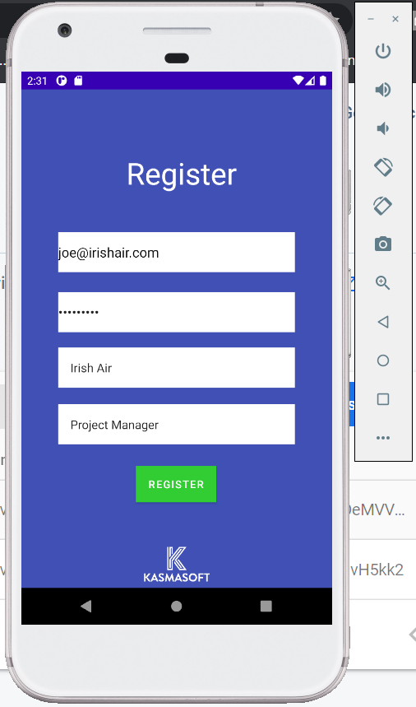

**DATABASE ON FIREBASE BEFORE REGISTERING THE USER**

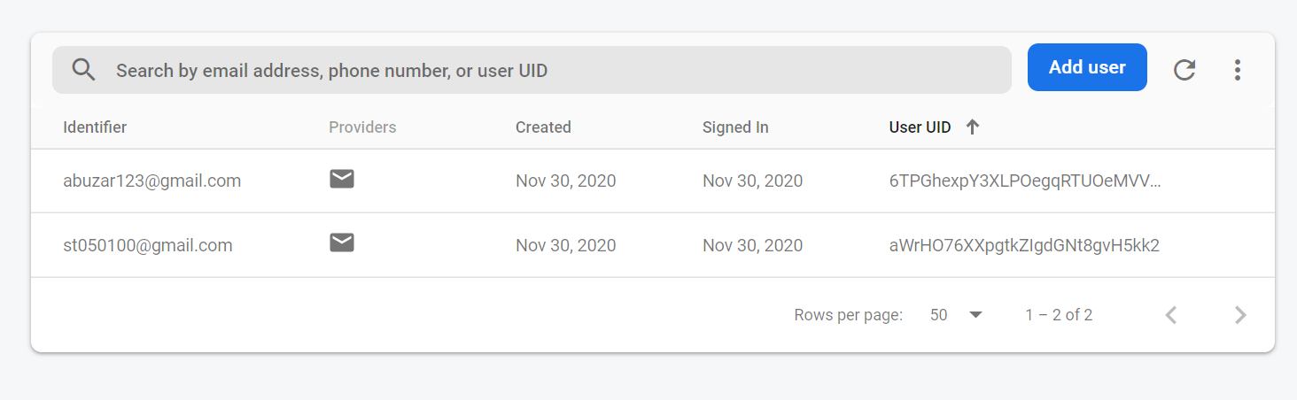

**DATABASE AFTER REGISTERING THE USER**

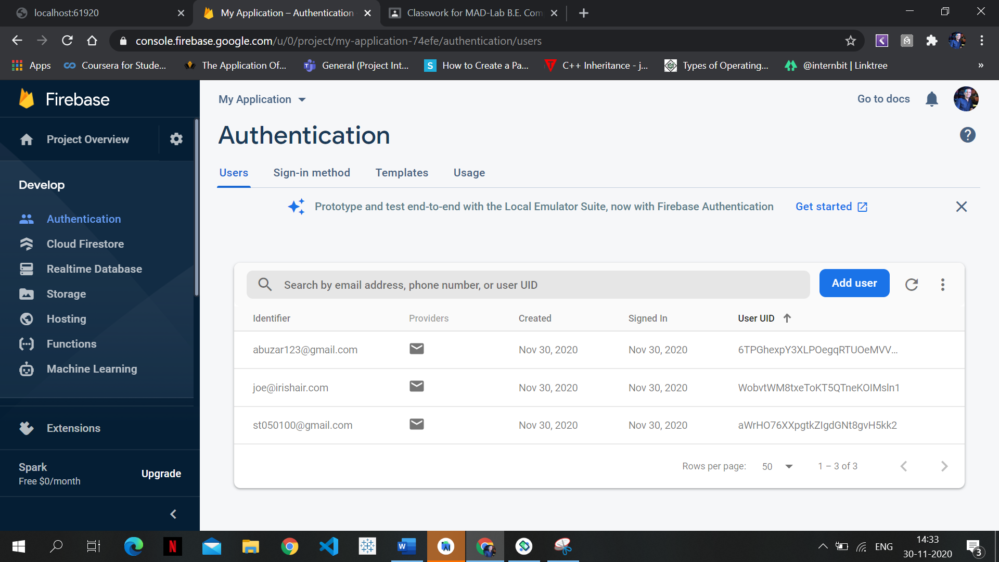

**LOGGING IN WITH THE USER**

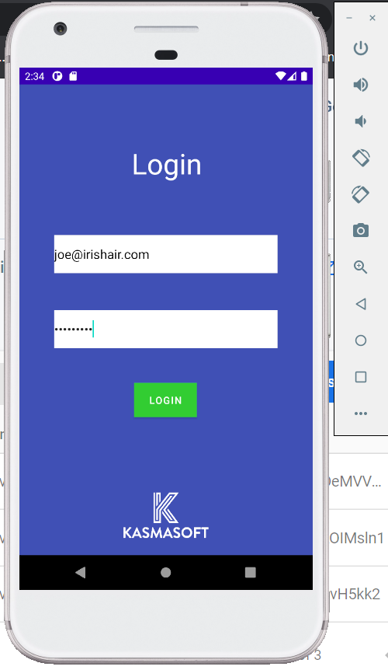

**PROMPT STATING SUCCESSFUL LOGIN**

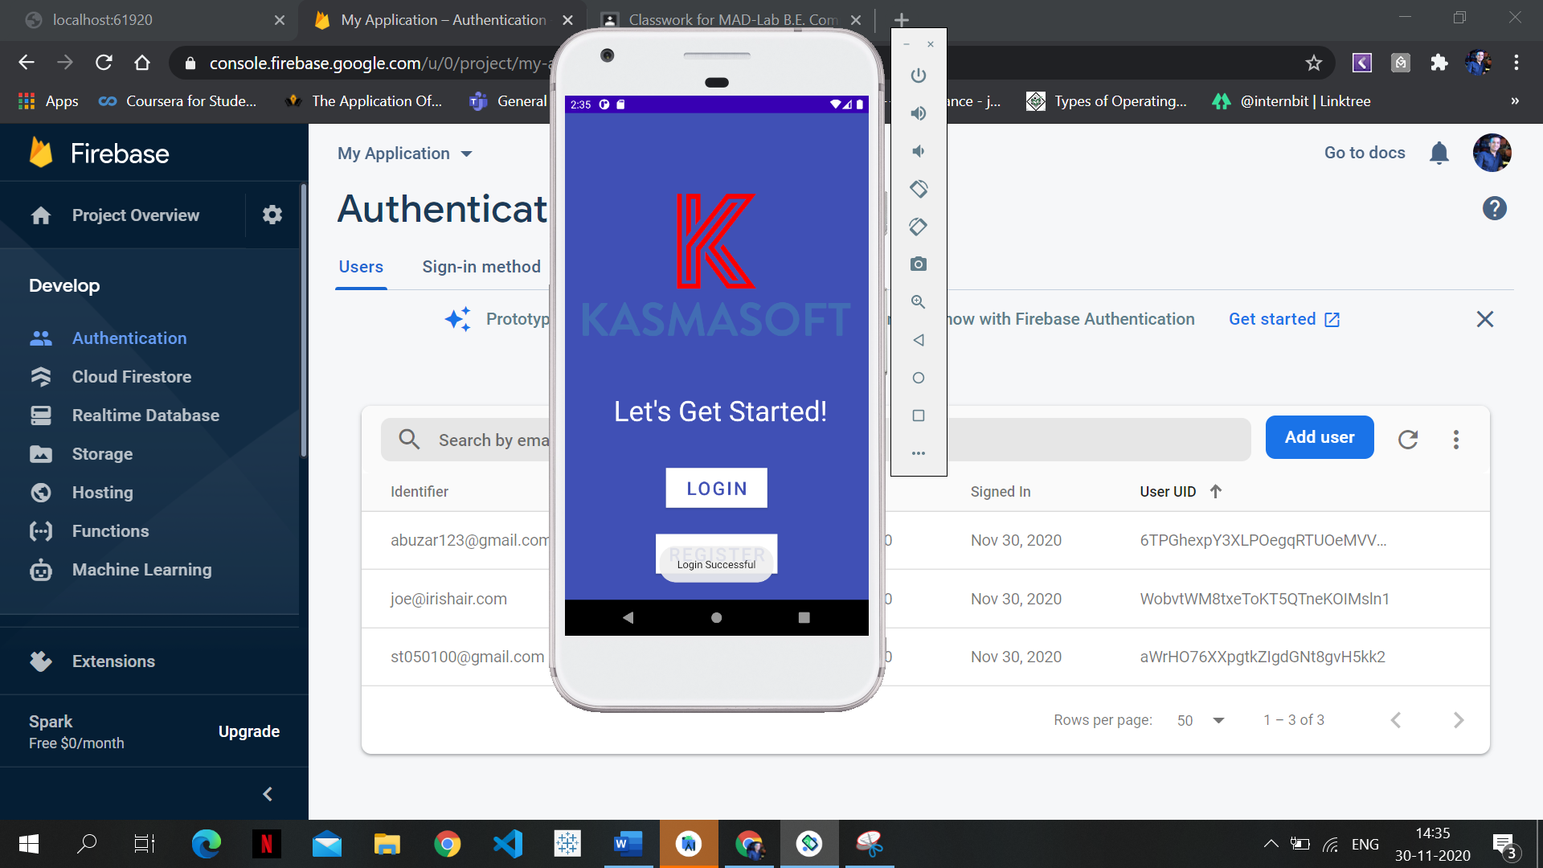

**INVALID PASSWORD CHECK**

